**Dynamic Modeling of Population Dynamics**

Henry Perillo, Vy Sanders, and Helen Streff

*Introduction to Biocomputing*

*Final Project–Dynamic Modeling*

*I.**Lotka-Volterra Model*

**1. Conceptual model**

*Arrows indicate the flow of energy

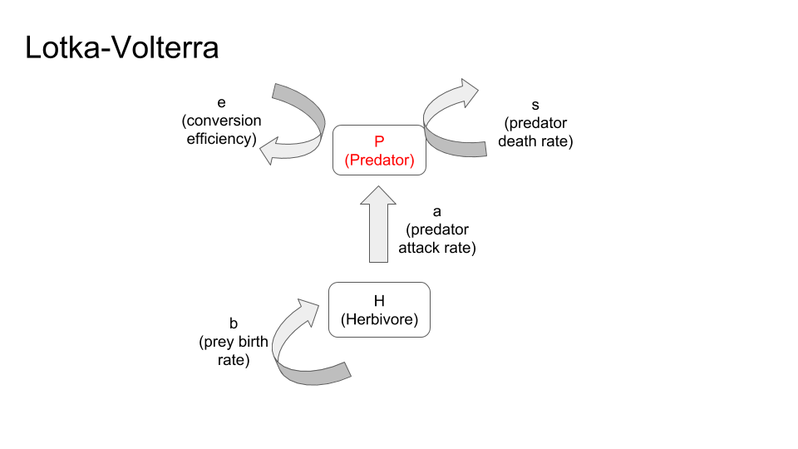

**2. Role of each parameter**

- Prey birth rate (b)- When prey birth rate increases, the amplitudes in both the predator and prey lines increases, but the number of cycles is unaffected. When the prey birth rate decreases, the amplitudes decrease and the number of cycles in a given length of time also decreases.

-Predator attack rate (a)- When predator attack rate increases, the delay in the predator population increasing or decreasing with respect to the prey shortens. Conversely, when the predator attack rate decreases, the delay in the predator population increasing or decreasing with respect to the prey lengthens.

-Conversion efficiency of prey to predators (e)- Increasing the conversion rate decreases the difference between the amplitudes of the two populations, while decreasing the conversion rate increases the difference between the amplitudes.

-Predator death rate (s)- Increasing predator death rate increases the amplitude of the prey population. Decreasing predator death rate decreases the amplitude of the prey population.

**3. Role of predators**

In the Lotka-Volterra Model, predators rely on the prey population for their survival, but also decrease the prey population. As the prey population increases, the predator population increases slowly, but as the prey population decreases, the predator population decreases after a delay.

**4. Relationship between parameter values and predator-prey cycle length**

-Prey birth rate (b)- When prey birth rate increases the number of cycles is unaffected. When the prey birth rate decreases the number of cycles in a given length of time also decreases.

-Predator attack rate (a)- When predator attack rate increases the number of predator-prey cycles in a given length of time increases. Conversely, when the predator attack rate decreases the number of predator- prey cycles in a given length of time decreases.

-Conversion efficiency of prey to predators (e)- Increasing the conversion rate increases the number of predator-prey cycles in a given length of time slightly, while decreasing the conversion rate decreases the number of cycles slightly.

-Predator death rate (s)- Increasing predator death rate increases number of cycles and the amplitude of the prey population. Decreasing predator death rate decreases number of cycles and the amplitude of the prey population.

**5. Models:**

|  |
| --- |
|  |
| **Figure 1. Lotka-Volterra Simulation with Initial Conditions.** Parameters- b=0.5, a=0.02, e=0.1, s=0.2 |

|  |
| --- |
|  |
| **Figure 2. Lotka-Volterra Simulation with changes to Prey Birth Rate (b) and Predator Attack Rate (a).** Panel (A) demonstrates a fourfold increase in prey birth rate, while panel (B) displays a two-fold decrease in prey birth rate. The change in panel (C) is a two-fold increase in predator attack rate, while panel (D) illustrates a two-fold decrease in predator attack rate. |

|  |
| --- |
|  |
| **Figure 3. Lotka-Volterra Simulation with changes to Conversion Efficiency (e) and Predator Death Rate (s).** Panel (A) demonstrates a two-fold increase in conversion efficiency, while panel (B) displays a two-fold decrease in conversion efficiency. The change in panel (C) is a two-fold increase in predator death rate, while panel (D) illustrates a two-fold decrease in predator death rate. |

*II. Rosenzweig-MacArthur Model*

**1. Conceptual model**

*Arrows indicate the flow of energy

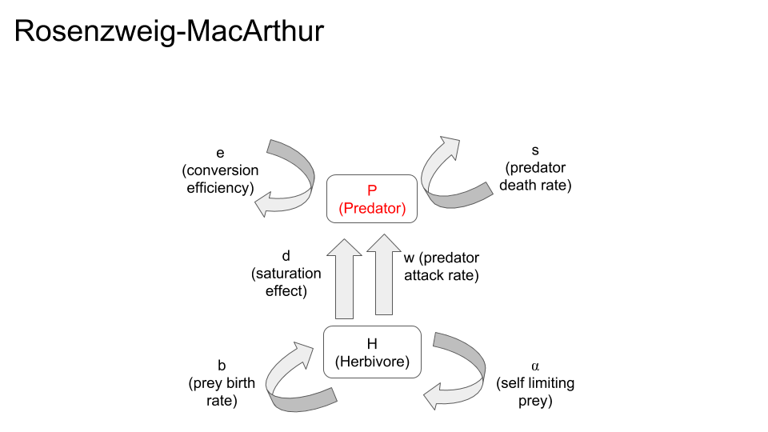

**2. How dynamics differ from LV?**

Rather than demonstrating a sinuous frequency like in the Lotka-Volterra model, the Rosenzweig-MacArthur model under the initial conditions demonstrates an equilibrium for both populations, rather than a cyclical pattern.

**3. What causes dynamics to differ between LV and RM**

The difference in dynamics is caused by the addition of the *w* term*,* which depicts the self-limiting nature of the prey population,and *d* term,which demonstrates the saturating functional response to predators as a result of prey density. The result of adding these factors is an increased influence of the ecological footprint and carrying capacity for prey populations in the absence of predators, as well as the effect saturation effect on the predator due to abundant prey.

**4. Relationship between parameter values and predator abundance**

-Prey birth rate (b) - When prey birth rate increases, the predator equilibrium population increases and the prey equilibrium population remains the same. Decreases in prey birth rate seem to not affect equilibrium populations too much; however, it is important to note a slight increase in prey population following the stabilization of the predator population.

-Predator attack rate (a) - Increase in predator attack rate sees a simultaneous decline in prey population until the predator population arrives at zero and the prey populations increase to carrying capacity. A decrease in predator attack rate allows for a lower-frequency cyclical pattern between populations.

-Conversion efficiency of prey to predators (e) - Two-fold increase of conversion efficiency changes the nature of the relationship from equilibrium to high-frequency cyclical. Decrease in conversion efficiency leads to a total decline of predator population, and an increase in prey population until carrying capacity is reached.

-Predator death rate (s) - Increase in predator death rate sees a quick drop in prey populations followed by a large increase toward carrying capacity while the predator population simultaneously decreases. A decrease in predator death rate sees a cyclical nature of predator and prey populations.

-Self-limiting prey (w) - Increasing the self-limiting nature of the prey results in high-frequency cycles of predator and prey populations, while decreasing the self-limiting nature of prey sees an instant rise in prey population toward carrying capacity while predators crash.

-Saturation effect (d) - Increases in the Type II saturation effect on predators lead to a small initial decline in prey followed by an explosion to carrying capacity. On the other hand, predator population constantly declines until extinction. Decreases in the saturation effect lead to a cyclical pattern with a large initial cycle followed by higher-frequency subsequent cycles.

**5. Models:**

|  |
| --- |
|  |
| **Figure 4. Rosenzweig-MacArthur Simulation with Initial Conditions.** Parameters: *b* = 0.8, *a* = 0.001, *e* = 0.07, *s* = 0.2, *d* = 400, *w* = 5. |

|  |
| --- |
|  |
| **Figure 5. Rosenzweig-MacArthur Simulation with changes to Prey Birth Rate (b) and Conversion Efficiency (e).** Panel (A) demonstrates a four-fold increase in prey birth rate, while panel (B) displays a two-fold decrease in prey birth rate. The change in panel (C) is a two-fold increase in conversion efficiency, while panel (D) illustrates a two-fold decrease in conversion efficiency. |

|  |
| --- |
|  |
| **Figure 6. Rosenzweig-MacArthur Simulation with changes to Predator Death Rate (s) and Self-Limiting Prey (w).** Panel (A) demonstrates a two-fold increase in predator death rate, while panel (B) displays a two-fold decrease in predator death rate. The change in panel (C) is a two-fold increase in self-limiting prey, while panel (D) illustrates a two-fold decrease in self-limiting prey. |

|  |
| --- |
|  |
| **Figure 7. Rosenzweig-MacArthur Simulation with changes to Saturation Effect (d) and Predator Attack Rate (a).** Panel (A) demonstrates a two-fold increase in saturation effect, while panel (B) displays a two-fold decrease in saturation effect. The change in panel (C) is a two-fold increase in predator attack rate, while panel (D) illustrates a two-fold decrease in predator attack rate. |

*III. Paradox of Enrichment*

**1. What happens as carrying capacity increases?**

As carrying capacity increases, the equilibrium between the predator and prey destabilizes and causes a more regular fluctuation like seen in the Lotka-Volterra model.

|  |
| --- |
|  |
| **Figure 8. Rosenzweig-MacArthur Simulation with changes to Self Limiting Prey Rate.** Panel (A) ⍺=0.00125(B) ⍺=0.0009 (C) ⍺=0.0006 (D) ⍺=0.0005. |

**2. Why do we see Paradox of Enrichment?**

The Paradox of Enrichment shows that as the carrying capacity of a population following dynamics of the Rosenzweig-MacArthur Model increase, the equilibrium established between predators and preys destabilizes and instead the populations follow a cyclical pattern like seen in the Lotka-Volterra model. This occurs because although the prey population can grow unbound with a high carrying capacity, the predator population can only grow unbound for so long before crashing from overpopulation. This further leads to destabilization of the prey population since the prey population grows beyond the carrying capacity when the predator population falls and the prey population subsequently falls dramatically before recovering back to carrying capacity.